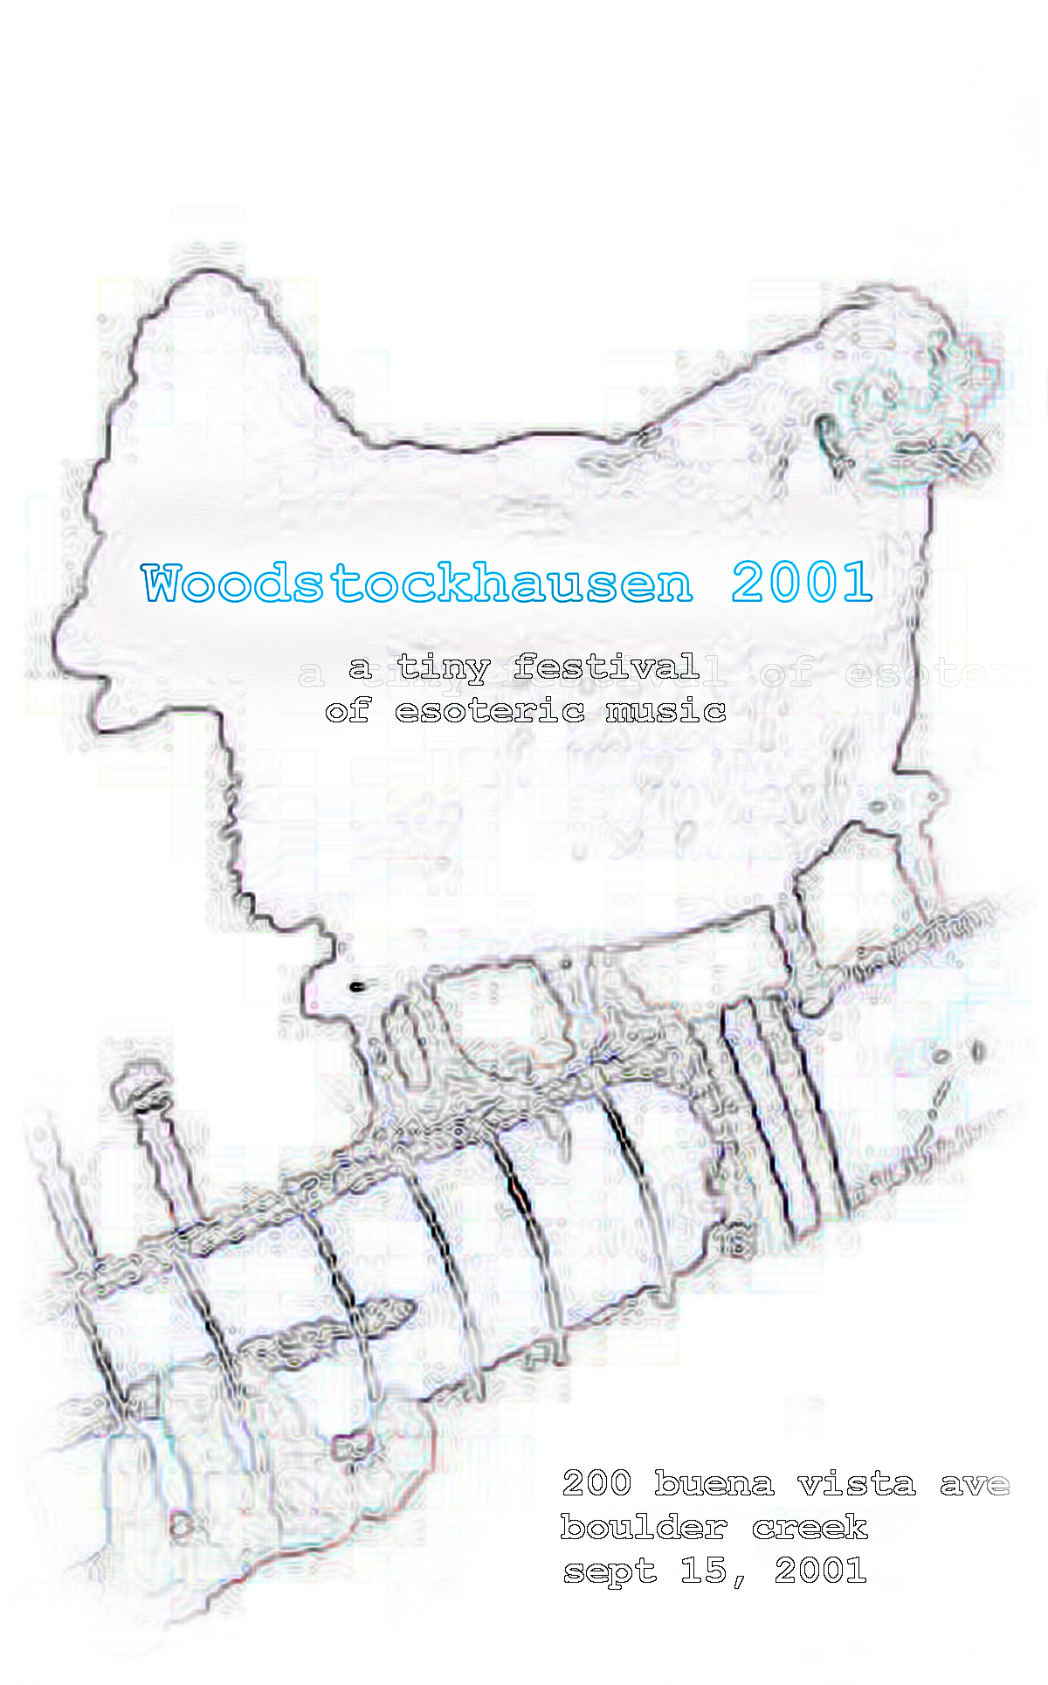

Woodstockhausen 2001

Concert Program

- Act I -

bþ?n danh tÿ (bu¹o¹n danh tu¹?) [bwundantuh]
by Richard Eldon Barber |  | 7’20”
 |  | Richard Barber, Trumpet
 |  | Rian Rodruigez, Trumpet
 |  | Michael Delacuesta, Trumpet
The Four Trumpets provide the only impulse which generates the music you will see and hear in this composition.

Two in the Hand
Richard Zvonar | 7’33”
Two in the Hand is a collaboration with bassist Robert Black, realized during a residency at the Banff Centre for the Arts in 1993. The piece is a blank-slate electroacoustic improvisation. Robert initiated the piece by playing a 30 second passage on the bass, and I captured a recording of this into two TC2290 sampling digital delays. These sampling units were controlled by my own software, created in the Max programming language. Playback of Robert's performance was done by a process of "windowing" - playing back of short loops of the bass sound and dynamically moving these sonic windows through the material while Robert responded in his continuing improvisational performance.

Suburban Stroller
by Scott Angel | ~6’00”
This piece was inspired during bouts of infant induced insanity (Autumn - stop jumping on your brother!). It includes experiments with adding computer generated audio (Model-E VST synthesizer for some funky synth mixes), sampled audio from "The Emperor's New Groove", pre-recorded MIDI tracks, and of course me playing along - I hope it all works! No children or animals were harmed during the creation of this performance.

Sacred Amnesia
Eric Lyon | 7’51”
Sacred Amnesia is a musical essay on the art of history creation through structured memory loss and transformation. Special programs were designed to achieve musical analogies to the historical process.

Empty Experiences
Trashotron (RIck Kleffel, Jinny Royer, Helen Sventitsky-Rother, others as arrived) | ~15’00”
Live and captured angels and daemons, looped and endless humans and machines.

Squiggle (for Sol)
Wayne Jackson | 3’48”
Dedicated with affection to Sol Friedman, who accidentally commissioned this piece when he once commented on one of my granular synthesis pieces with the statement: "...but Wayne, I thought your music was more squiggly than that."

All source sounds evolved with Selectasynth.

Oops, I made a typo()
Tim Thompson | ~10’00”
"Oops, I made a typo()" is a live improvisation using a typing keyboard as the only form of input and control. Keystrokes (up and down) are interpreted by a function named typo() written in the KeyKit programming language, and MIDI output is generated. The keyboard will be played like an instrument, with real time input of melodies and rhythms that are looped, layered, and transformed.

Hepturnsjui
Richard Eldon Barber | ~6’00”
Automatically generated by software, recorded, and then arranged into a composition. The purpose of Hepturnsjui is an automatic simulation of a binaural hearing test that presents different triads to each ear simultaneously. The result is extra-musical and probably could show that people with hearing difficulties may not be able to recognize the immediate succession of common triads when presented simultaneously/binaurally.

Rick Walker’s Loop.pooL
Rick Walker | ~15’00”
John Coltrane is attributed to have said, "All instruments aspire to the human voice". It is unlikely that he had Rick Walker's idiosyncratic use of that quirky instrument in mind when he said it.

Although Rick's solo performances as Loop.pooL normally feature pieces for instruments as diverse as found sound percussion, prepared/treated guitars and bass, wind instruments to bowed crotales, tonight's composition "VOIX" will feature only his voice, real time digital processing and you, the audience. He will incorporate a repertoire of unusual and exotic vocal techniques (overtone singing, warble singing, trill singing, guttural singing, hum-whistling, mouth percussion and effects, yodeling and pygmy bottle blowing/falsetto singing).

He will also incorporate digital processing and production techniques, using analog filters, vocoders, digital delays and modulators to modify his performance.

In tonight’s performance, Rick will insist that everyone participate. He asks that people please not shirk this awesome and terrifying responsibility.

Mote
Wayne Jackson | 6’44”
A composition of evolved sounds, smeared into a relaxing cloud via granular synthesis. Think of it as acoustic finger painting. Do you note timbral similarities to another piece on this program?

a suggestion
Jack Culpepper | ~5’00”
This is a special track, in a series of works which define my own personal musical genre: electrogroovitoricalspacejazz. If you are expecting something terrible harsh or disturbing, I'm afraid you're going to be disappointed. My music is built from relatively melodic phrases, artfully (I hope!) layered upon each other, and intertwined with rhythmic, groovalicious beats. It is pretty simple stuff. I don't claim to be doing anything extraordinary, except passionately avoiding categorization.

- Act II -

The Enchanted Jackhammer
and other revisionist tales to frighten small children
Gary Hull | ~15’00”
This soundtrack illuminates the exceedingly morose tale of a small child who unknowingly uses her latent telekinetic ability to animate a large hydraulic construction tool as an element of revenge against her unsuspecting parents. Chaos ensues, and of course “a splendid time is guaranteed for all”. So, join us now on this dark rainy evening as the Enchanted Jackhammer rises, flaming and popping, over the whimsical disarray of the old abandoned construction site……

Jifnowyayuh
Richard Eldon Barber | ~4’00”
Automatically generated by software, recorded, and then arranged into a composition. Jifnowyayuh explores an alternative synthesizer tuning procedure and probablity in generating tone and noise. There is a musical scale, but it is only hinted at because of the melody's near-randomness!

I’ll Just Phone In My Part
Craig Latta | 7’01”
Hello? Is this 415.260.2770? Yeah, it's me. He asked me to just phone it in. The piece? Yeah, it's going okay, I guess. It has a certain ring to it, ha ha ha. Uh, yes, I'll hold.

Alien Indigestion
James Gideon | 4’00”
Please share your Rolaids with the Aliens.

Tape Recorder
Matt Davignon | ~11’00”
Improvising from pre-recorded city sounds.

Frikkit!
Richard Zvonar | 11’25”
Frikkit! is an octaphonic tape piece for playback through eight matched loudspeakers, equally spaced in an octagonal planar array. In case a full eight channels are not available, the piece can be diffused through a smaller number of speakers provided that the eight tape tracks can be mixed and panned for surround sound. The playback medium is ADAT, 16-bit at 44.1 kHz.

The source material for this piece consists entirely of the sounds of crickets, frogs, and toads.

Diablo Variations
Richard Zvonar | 5’44”
Diablo Variations was composed on a Yamaha CX5 computer music system. The sounds were produced by 4-operator FM synthesis and the compositional process was based on a free cut-and-paste process.

Beam
David Van Brink | ~8’00”
"Beam" is a short piece composed using the third iteration of my music sequencing software, "Synthestra". (The first two iterations were for Apple ][, and written in the early 1980's.) Additionally, some of the audio synthesis is performed using handcrafted Verilog modules downloaded to an FPGA device.

The music? Enh. Something engaging with a beat. You'll like it. Especially since you'll be able to play along with it from the comfort of your own audience seat.

entwined
John Michael Zorko, aka Falling You | 4’23”
She loomed over me, eyes of stars, the cosmos interweaved through her hair as her mouth opened to me and the figure came, a faint vesper against her blackness. It moved through her, around her; against the dark matter which made her, it danced with sun and moon to the beautiful noise of the universe.

"... and I awoke from this dream -- chilled, numb, and wonderfully serene."

"And what did this dream mean to you?"

Schizando
Luke Dahl | ~5’00”
This is a failed attempt to throw off the restraints of regular rhythmic structure and harmony. Turns out them chains can be kinda nice. Witness the struggle!

Passive Scan
Wayne Jackson | 9’54”
This piece owes its inspiration entirely to Tim Stilson. Approximately a year ago Tim and I were discussing alternative synthesis techniques when the topic of Max Mathews and his “radio bongers” came up. Dismissing the “radio bongers” as something that Mathews probably should have blamed on someone else as soon as he had the opportunity, we chanced upon his Scanned Synthesis algorithm as something considerably more interesting to talk about. (I had the good fortune to hear Mathews describe this algorithm in person while working at the E-mu Technology Center, now ATC). It turns out that Tim had also thought about Scanned Synthesis for quite some time. He had his own ingenious ideas about how to control it using Cellular Automata, and I promised to quickly implement software to explore this. Now, a year later, I’ve finally kept that promise and this piece demonstrates a very small cross-section of the possible sounds…

Stanley Kubrick Memorial Orchestra | ~20’00”
May be offensive to some primates. This might be a good time to leave.

Credits

Scott Angel - | Internet video broadcast
Richard Eldon Barber - | Web Master / Stage Manager
Wally Beck - | All-around Handyman
Amy Burnett - | House Manager / Sales
Bob Cain - | Stage Manager
Doug Cook - | Mailing List
Tyson Dobrinen - | Sound/Equipment
Duane Ford - | Lights
Gary Hull - | Equipment
Wayne Jackson - | Portable Toilets / Maunderings
Jean Marc Jot - | Sound/Equipment
Alan Peevers & Oozic Team - | Generative Video
Dave Tristram - | Viviography

Audionauts

Scott Angel
Hi! I'm Wayne's neighbor. Look for the cow! I spend most of my free time chasing after the kids or working on our ever-changing project house.

Richard Eldon Barber
Richard Eldon Barber is an undergraduate electro-acoustic music major at San Jose State University. He is studying composition, bassoon, and clarinet there, as well as experimenting in computer generated music-art.

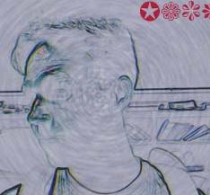
Jack Culpepper
I am a 24-year-old dreamer, space cadet, and perpetual motion machine. I can't do anything for very long without becoming incredibly bored. Thus, I have recently dislodged myself from corporate stodginess, in favor of a simpler, educational lifestyle, where I can pretty much do as I please. I spend a great deal of time teaching myself and others about computers, and gradually understanding that I will never know everything I want to. When things don't go my way, I try not to get upset. There is no right or wrong...the only certainty is that time is passing.

Luke Dahl
Luke Dahl works in a Soundcard mine by day, and practices his glitchster clickrock dance moves by night. During Luke's 4 year WSH stint he has accumulated more and more equipment while having less and less of a clue about what to do with it all. This is very exciting!

Matt Davignon
Matt Davignon has been making unusual music since 1994, on a variety of instruments and themes. He has played and occasionally still plays modified acoustic guitar, bass guitars casio keyboards, found objects, samples, and cheap "squash-box" type guitar pedals.

For the "Tape Recorder" project, Matt carried a hand-held tape recorder with him for several months, collecting interesting sounds from around the bay area. He has been composing music at home using these sound sources, but this will be his first attempt at using them in a live improvisational setting.

James Gideon

James has been playing and tweeking with odd musical instruments for many years. He is the owner of Mad Science studio in Santa Cruz where he specializes in building custom analog stnthesizers for his own devious endevours. To find out more check out http://www.SiliconBreakdown.com.

Gary Hull

Gary Hull <http://www.garyhull.net> lives in a small, over-priced rental deep in the heart of Santa Cruz with his incredibly understanding wife Laurel, their two perpetually warring cats, and an ever-increasing pile of questionably useful musical detritus. Laurel swears that it will not completely take over the house, not on her watch, anyhow. Gary often describes his style as “guitar primitive” - a congenial mix of high-tech processing and low-brow guitar abuse. The happy medium between these two produces an effect that is often described as “stranger than Hollywood, even”. Gary’s mother has stated that his keyboard playing is “a lot prettier”. We may never know.

Wayne Jackson
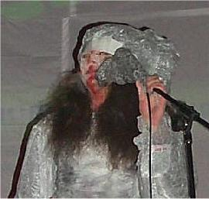
<wayne@darwinarts.com> aka Later Days likes to mix pain medication and audio synthesis software development in his scarce free time. He continues to be unreasonably inspired by the latter half of Dr. Wayne Slawson’s unintentionally profound remark: “People shouldn’t have to use psychedelic drugs to enjoy music, the music itself should be psychedelic.”

Sometime back in the early ‘90s, Wayne held the Back Porch Productions experimental music concerts, with the help of friends. These occured in his back yard in Davis using garage sale audio gear. Four years ago, with the collaboration of Doug Cook and many of the individuals in this program, he revived the tradition on a much larger scale via the Woodstockhausen tiny festival of esoteric music, which you are all sitting around reading this program instead of listening to.

Part of Wayne’s schtick is to do things from scratch. In the last four years he has written tools to evolve new electronic sounds using the Genetic Algorithm (assisted by copious quantities of beer and marijuana), a granular synthesizer (on Vicodin after a knee operation), an evolved audio mix generator (red mushrooms with white speckles all over them, quite prevalent around the Santa Cruz Mountains in the month of February), Tools for generative mutating loops (spinning rapidly in circles with his eyes closed, etc.)…

Current public releases include a series of self-published CDs available through MP3.com (http://www.mp3.com/laterdays), the do disk in the long-awaited Fällt invalidObjects compilation (http://www.fallt.com), and a stack of really cheap CDRs on the table behind you. Wayne actively fantasizes he will someday get rich selling experimental electronic music. He can’t understand why he has been urged to seek therapy for this.

Wayne also likes sitar music and chickens. Often at the same time.

Jean Marc Jot
Jean-Marc Jot <jmj@atc.creative.com> has spent a large part of the past ten years researching and developing algorithms and tools for the spatialization and artificial reverberation of sounds. He worked at IRCAM in Paris from 1992 to 1998, where he developed the Spat~ software using Max/MSP and collaborated in a number of musical productions and recordings. He joined the Creative Advanced Technology Center in Scotts Valley in 1998 to lead the research and development of Creative's 3D audio and EAX technologies.

Craig Latta
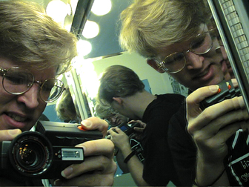
Craig Latta <Craig.Latta@NetJam.ORG> is rather tall. He studied music composition at UC Berkeley, where most of the doorways were too short. Forced underground, he consorted with various questionable types at the computer music studios of UCB and Stanford, becoming infected with a severe case of Smalltalk in the process. Shortly after joining the real world, Craig started the NetJam project, an experiment in networked musical collaboration. As the years passed, he began to accumulate an assortment of small, shiny devices which break easily. He has taught them to sing for your amusement this evening.

Eric Lyon
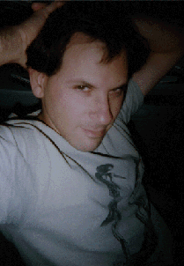
Eric Lyon composes instrumental, computer and web music and is currently on the faculty of Dartmouth College. Lyon's music and programs can be found at: http://arcana.dartmouth.edu/~eric and CDs of his computer music are available from EMF (www.emf.org) and his scores from Frog Peak (www.frogpeak.org).

Tim Thompson
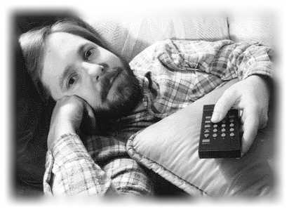
Tim Thompson worked at Bell Labs for 20 years before escaping to the real world in Silicon Valley. He wrote a custom MIDI programming language and GUI environment, called KeyKit, to simplify his developement of algorithmic and real time music software. The typo() instrument is included in the latest version of KeyKit, which is freely available at http://www.nosuch.com. Tim's web site also has a lot of algorithmic music toys that can be controlled through a web browser.

Trashotron
Rick Kleffel is a Gentleman of Leisure currently residing in Aptos, Jinny Royer is trapped in amber, Helen Sventitsky Rother is a wandering voice.

Dave Tristram

David Tristram <david@tristram.com> uses computers and video equipment to create a new form of dynamic improvisational visual art, called Viviography.
Simply put, Viviography is the art of creating art in motion. Derived from the Latin prefix "vivi" or "alive," Viviography uses the power of modern computers to create images that are born on the screen, then advance, retreat, shift, ascend, or disappear at the artist's bidding. Viviography allows the artist to achieve the spontaneity of jazz performance in a visual medium. When accompanied by music, Mr. Tristram's Viviography can engender a synaesthetic response in the viewer, where audience members report the experience of seeing music, or hearing pictures.
Viviography first came to be in the early 1990's when the advent of the graphics workstation allowed Mr. Tristram to bring controllable real time 3D imagery to live performance. In 1992, Mr. Tristram toured with the Grateful Dead. Shortly thereafter, Mr. Tristram founded the computer graphics performance ensemble Raster Masters, and with them refined Viviographic technique, collaborating with musical artists as diverse as Live, Fishbone, Morphine, and Herbie Hancock. Over a period of three years, Raster Masters performed nationally and internationally before audiences of as many as 50,000.
Now, using fast and inexpensive 3D cards for the PC in combination with low-cost video sources, Mr. Tristram is creating Viviography with the next generation of lightweight tools. Through the consulting firm Tristram Visual, he has created video art and software for corporate clients and has performed at new music concerts in the San Francisco Bay Area and throughout the Pacific Northwest. Tristram Visual also partners with other technology companies interested in accessing Viviographic tools.


David Van Brink
David Van Brink has been dabbling in electronic music ever since he first wired up a 555 to a speaker in 1977.

Then the 1980's happened:
http://artists.mp3s.com/artists/151/schrdingers_band.html
http://artists.mp3s.com/artists/151/david_van_brink.html

And then David implemented MIDI for Apple Computer's "QuickTime."

And then David attempted to turn a bunch of academic music software into a viable commercial implementation.

And then David got back into 555's.

Rick Walker
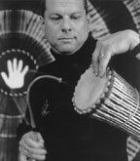
Composer, multi-Instrumentalist and master percussionist/drummer, Rick Walker has been on the cutting edge of music for the last 25 years. One of the original founding architects of the WORLD BEAT movement and now, as one of the leading lights in the emerging Looping/Electronica movement in Northern California, he incorporates a vast number of world music and pop styles in his repertoire.

Rick Walker's Loop.pooL is a fascinating and creative one man journey through the world of sound and rhythm. Using digital live looping technology, Rick is able to play a completely different set of instruments on every single song in this early twenty first century version of a "one person's band". He uses these 'loopers' to create repeating real time recordings of the instruments that he plays so that he can quickly change instruments and add other interesting layers to his real time composition.

Loop.pooL has performed at venues from Museum Art Galleries to10,000 person Massiv Raves. He has played for Silicon Graphics executive power dinners as well as free performances at Santa Cruz's Rio Theatre. He will play anywhere for any occasion because he thinks of Live Looping as the folk music of the future.

Rick is an exceptionally versatile and sensitive musician and is eccentrically creative, finding rhythm and melody in hundreds of everyday objects.

John Michael Zorko
John Michael Zorko is the main force behind Falling You (http://www.mp3.com/fallingyou -- ethereal female vocals, ambient soundscapes, experimental sound treatments) and Lead (http://www.mp3.com/l-e-a-d -- dark ambient, noise experiments).
influences:
Brian Eno, Jeff Pearce, Skylab, Cindytalk, Angelo Badalamenti, David Sylvian, Human Mesh Dance, Mick Harris, Matmos, Tetsu Inoue, Robert Rich, Philip Glass
similar artists:
Lull, Seefeel, Portishead, Enya, Maeror Tri, Nurse With Wound, Sian, That Summer

Richard Zvonar, PhD
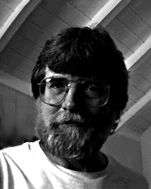
Richard Zvonar is a California composer and intermedia artist. His works include pieces for voice, acoustic and electronic instruments, tape, film, installations, music theater and intermedia performance. Zvonar received a PhD in Composition and Music Technology in 1982 from UC San Diego, where he was a Research Assistant at the Computer Audio Research Lab (CARL) and a Fellow at the Center for Music Experiment (CME). He has been artist-in-residence at the MIT Media Lab, Yellow Springs Institute, Real Art Ways, the Banff Centre for the Arts, and Studio PASS. Performances of intermedia works include soul murder (1983) at Berkeley Stage Co., The Board Room (1985) at S.F. Museum of Modern Art, Q (1986) at New Music America in Houston, OX (1987) in Kala Institute's Seeing Time series. Performances of electroacoustic music, featuring computer controlled processing of acoustic sounds, include an ongoing project with bassist Robert Black (Real Art Ways, PASS, Experimental Intermedia Foundation, Composers' Forum), Hex (1987) with the ensemble Relache in Philadelphia, several years touring and recording with avant-diva Diamanda Galas. Most recently, Zvonar has been developing his own performance control software using the Max programming environment.

Special Thanks to…

The Fern/Buena Vista neighborhood, for tolerating Woodstockhausen yet another year

Rebecca and Cloe Jot, for loaning us Jean Marc so close to the advent of his renewed fatherhood (CONGRATULATIONS!)

Tyson Dobrinen and Dave Tristram, whose effort and contributions extend above and beyond

Sylvia Lang, for her tolerance and good will above all others

ChainCast, for the live internet audio broadcast of WSH 2001

Brian Salter, for the name “Woodstockhausen”.

Max Mathews, “just for being you”

goodnight.

